Department | AIDS
Course Code / Course Name | DSA0602/ Data Handling and Visualization
Experiment | Data Visualization using R
Name | Ayesha Siddiqa S
Register Number | 192324305
Date | 10/10/2026
Day | Saturday
Set 17: Employee Performance Analysis

1. Line chart — Employee performance over time
Aim: To visualize employee performance scores in relation to years of service.
Algorithm:
- Create the employee performance data frame.
- Load ggplot2.
- Plot years of service on the x-axis and performance score on the y-axis.
- Add points, a connecting line, a title, and axis labels.
Code:
if (!requireNamespace("ggplot2", quietly = TRUE))
install.packages("ggplot2", type = "binary")
library(ggplot2)

employees <- data.frame(
ID = c(1, 2, 3),
Department = c("Sales", "HR", "Marketing"),
Years = c(5, 3, 7),
Score = c(85, 92, 78)
)

ggplot(employees, aes(x = Years, y = Score)) +
geom_line(color = "blue") +
geom_point(size = 3, color = "red") +
labs(title = "Employee Performance by Years of Service",
x = "Years of Service",
y = "Performance Score") +
theme_minimal()
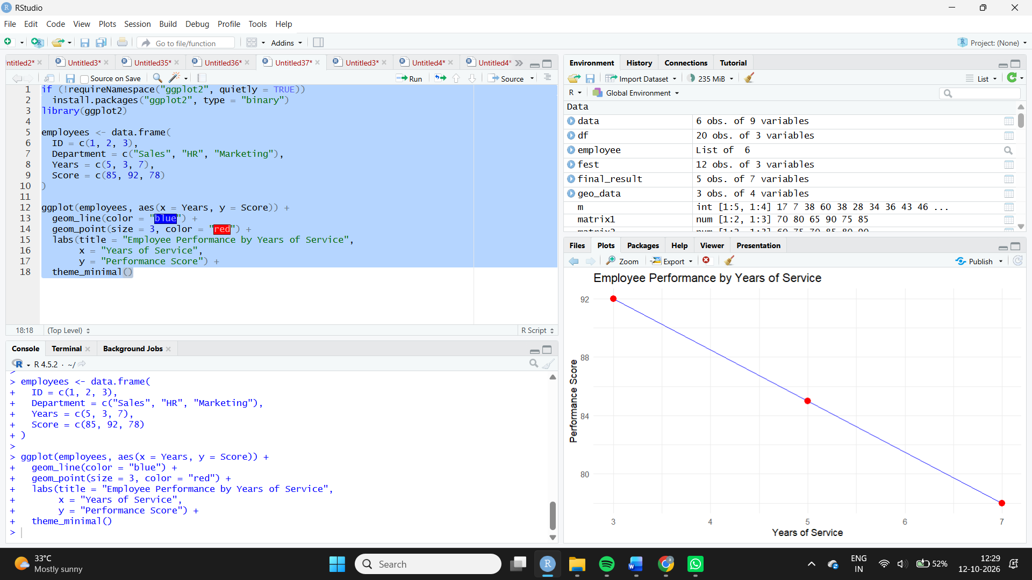
Observation: The HR employee has the highest performance score of 92, with 3 years of service. The Marketing employee has the lowest score of 78.
2. Bar chart — Employees by department
Aim: To visualize the number of employees in each department.
Algorithm:
- Count employees by department.
- Map department to the x-axis.
- Draw bars representing employee counts.
- Add a title and axis labels.

Code:
ggplot(employees, aes(x = Department, fill = Department)) +
geom_bar() +
labs(title = "Employee Distribution by Department",
x = "Department", y = "Number of Employees") +
theme_minimal() +
theme(legend.position = "none")
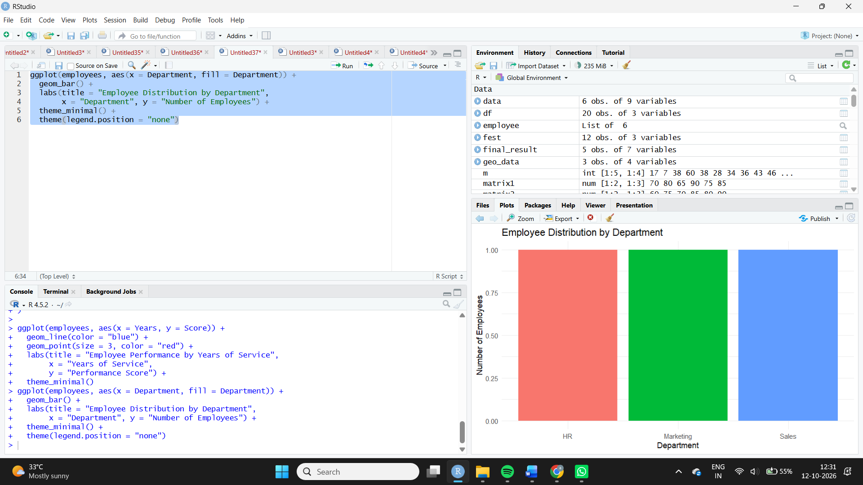
Observation: Each department has one employee. Therefore, the distribution is equal across Sales, HR, and Marketing.
3. Employee performance table
Aim: To display employee IDs, departments, years of service, and performance scores.
Algorithm:
- Store the employee records in a data frame.
- Assign descriptive column names.
- Print the table.
Code:
print(employees)

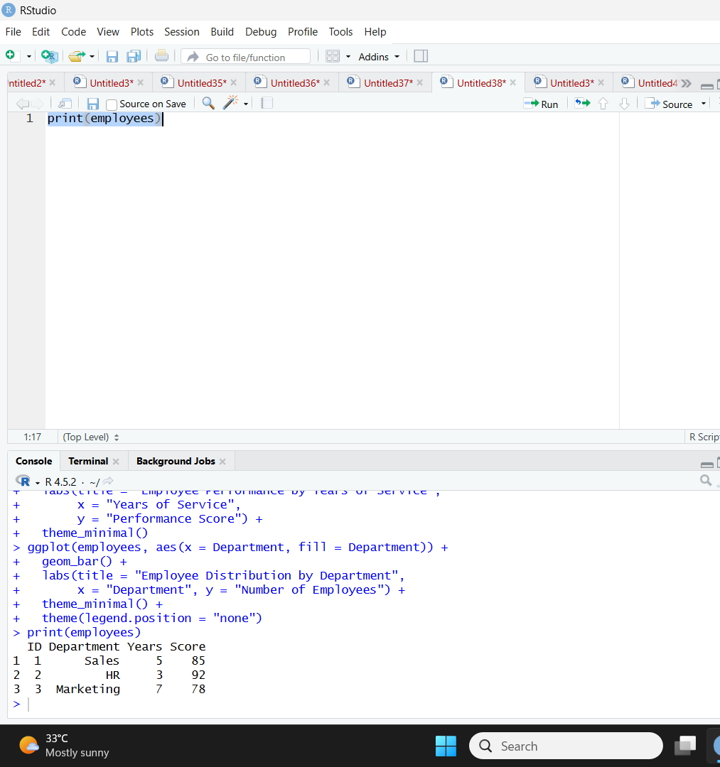
Observation: The table provides a clear comparison of performance scores and service years for all three employees.
4. Tableau dashboard
Aim: To combine the performance line chart, department bar chart, and employee table into an interactive dashboard.
Algorithm:
- Import the employee dataset into Tableau.
- Create a line chart using Years of Service and Performance Score.
- Create a department bar chart using Employee ID as a count.
- Create a table containing all employee details.
- Combine the worksheets into a dashboard and add filters.
Procedure in Tableau:
- Connect to the employee dataset.
- Create the line chart by placing Years of Service on Columns and Performance Score on Rows. Add Employee ID to Detail.
- Create the department bar chart using Department and COUNT(Employee ID).
- Create a table with Employee ID, Department, Years of Service, and Performance Score.
- Add all three worksheets to a dashboard.
- Add a Department filter and enable Use as Filter on the department chart.
Observation: The dashboard allows users to compare employee performance, departmental headcount, and individual employee records.

